A Simple Design Methodology
for Passive Solar Architecture

Dennis Holloway, Architect, An Architect in Northern New Mexico

By Dennis R. Holloway (the die-hard solar architect!)
Author's Note: The following information is a precipitation of knowledge acquired through my practice and research in the 1970's regarding the use of solar energy to 'passively' heat and cool buildings. I believe that continuing dissemination of this information through the Internet is very important in a time when earth's bio-environment is so endangered by the continued combustion of fossil fuel into the atmosphere. Please copy this page and distribute it freely.
The ancient discovery that the shadow of a "gnomon"--an arrow stuck vertically into the ground--mirrored the perfectly symmetrical path of the sun across the sky is as important to the development of civilization as the discovery of the wheel. By studying the movements of this shadow people first conceived of the 90o (right) angle--the foundation of geometry, and ultimately of architecture. A result of this "shadow science" origin is that most architecture and city street grids are related to the north-south east-west axes. The ancients also gained great insights into the potential of architecture to modify the sun's shadow and radiant heat.
Indeed, using the sun as a heat source is nothing new. In XENOPHON'S MEMORABILIA, written 2400 years ago, Socrates observed:
"Now in houses with a south aspect, the sun's rays penetrate into the porticos in winter, but in the summer, the path of the sun is right over our heads and above the roof, so that there is shade. If then this is the best arrangement, we should build the south side loftier to get the winter sun and the north side lower to keep out the winter winds. To put it shortly, the house in which the owner can find a pleasant retreat at all seasons and can store his belongings safely is presumably at once the pleasantest and the most beautiful."
While the Greek house that Socrates described probably lost heat as fast as it was collected, due to convective and radiation losses, the Romans discovered that if the south-facing portico and windows were covered with glass, the solar energy would be trapped causing the internal temperature to stay constant into the night. This simple phenomenon called the "greenhouse effect" is illustrated by the experience of returning to your car on a sunny, cool day and finding it overheated. Today we call the house that uses the greenhouse effect for heating a "passive solar house."
It is a common rule-of-thumb that compared to a conventionally designed house of the same square footage; a well-designed passive solar house can reduce energy bills by 75% with an added construction cost of only 5-10%. In many parts of the U.S. passive solar houses do not require any auxiliary energy for heating and cooling. Given current and future projected fuel costs, the additional construction cost is recovered quickly. Official surveys show 100,000 passive solar homes in the U.S. (1984), but informal estimates bring to one million the number of buildings that employ some aspects of passive solar design, often south-facing greenhouses.

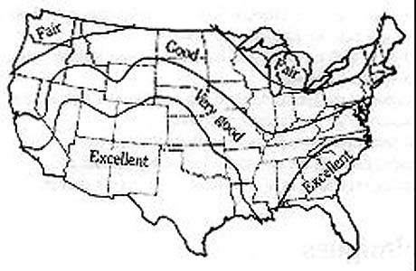
Figure 1: Potential for passive solar heating in the United States.

Characteristics of a Passive Solar House
The Passive Solar House has some distinctive design features:
1. In the northern hemisphere most of its windows are facing the south (in the southern hemisphere its windows face north). Solar radiation, mostly the visible light spectrum, passes through the solar-oriented glass of windows or solar spaces, and is absorbed by surfaces of materials inside the insulated envelope of the building. As these heated surfaces re-radiate the energy into the interior of the house, the air temperature rises, but the heat is not efficiently re-radiated outside again through the glass, nor can the heated air escape, so the result is entrapped energy.
2. Ideally, the interior surfaces that the light strikes are high density materials, such as concrete, brick, stone, or adobe. These materials, because of the "flywheel" effect (the ability to absorb energy and re-readiate it over time), can store the energy for constant slow re-radiation, resulting in a very smooth temperature swing curve for the building, and reducing the possibility of overheating the air in the house. In this way a large portion of the houses' heating requirements can be supported by the sun.
3. In the early passive solar houses of the 70's, architects and builders tended to reduce window areas on the east, west, and north sides of the house in favor of southern orientation. This is still the general rule-of-thumb, but the introduction of energy conserving and radiation-modifying films, available in several major window lines (see Chapter 6, p. 57f), enables designers and builders to relax this rule. This is good news on sites with attractive views other than to the south. West windows are a source of high heat gain during the summer, and should be shaded. Generally, the house plan with a long east-west axis and optimized south-facing wall will be the best passive solar house.
4. Passive solar homes tend to be well insulated and have reduced air leakage rates, to keep the solar heat within the building envelope.
5. Since auxiliary heat requirements are greatly reduced in a passive solar home compared to a conventional home, smaller, direct-vented units or a woodstove for extended cloudy periods are often the heaters of choice.
6. Passive solar homes often have "open floor plans" to facilitate the "thermosiphing" movement of solar heat from the south side through the rest of the house. Sometimes small fans are used to aid in warm air distribution in houses with "closed floor plans".

Passive Solar Techniques 1: Direct Gain
There are two basic ways passive solar houses gain solar energy, direct and indirect gain. Direct gain houses, considered to be the simplest type, rely on south-facing windows, called solar windows. These can be conventionally manufactured operable or fixed windows on the south wall of the house or standard-dimension insulating glass panels in the wall of the sunspace or solarium. While some of the heat is used immediately, walls, floors, ceilings, and furniture store the excess heat, which radiates into the space throughout the day and night. In all cases the performance and comfort of the direct gain space will increase if the thermal mass (concrete, concrete block, brick, or adobe) within the space is increased.

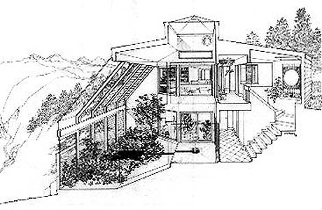
Figure 2: A direct gain passive solar house (Design by Dennis Holloway, Architect, for Ellen and Matt Champion)
J. Douglas Balcomb and his research team at Los Alamos National Laboratory recommend that the mass be spread over the largest practical area in the direct gain space. It is preferable to locate the thermal mass in direct sunlight (heated by radiation) but the mass that is located out of the direct sunlight (heated by air convection) is also important for overall performance. Thermal mass storage is as much as four times as effective when the mass is located so that the sun shines directly on it and it is subject to convective heating from warmed air as compared to only being heated by convection. The recommended mass surface-to-glass area ratio is 6 : 1. In general, comfort and performance increase with increase of thermal mass, and there is no upper limit for the amount of thermal mass.
Remember, covering the mass with materials such as carpet, cork, wallboard, or other materials with R-values greater than 0.5 will effectively insulate the mass from the solar energy you're trying to collect. Materials such as ceramic floor tiles or brick make better choices for covering a direct gain slab. Tiles should be attached to the slab with a mortar adhesive and grouted (with complete contact) to the slab.
In direct gain storage thin mass is more effective than thick mass. The most effective thickness in masonry materials is the first four inches--thickness beyond 6" is pointless. The most effective thickness in wood is the first inch.
Locating thermal mass in interior partitions is more effective than exterior partitions, assuming both have equal solar access, because on the internal wall heat can transfer on both surfaces. The most effective internal storage wall masses are those located between two direct gain spaces.

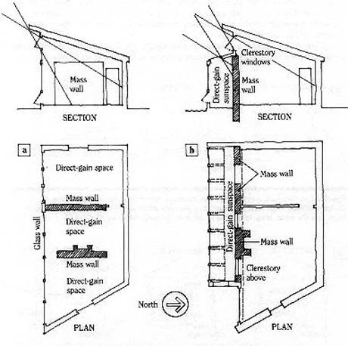
Figure 3: Internal mass storage walls serve as north-south partitions between direct -gain spaces (a) and as east-west partitions between direct-gain sunspaces and north clerestory space (b).
Lightweight objects and surfaces of low density materials should be light in color to reflect energy to high density materials. If more than one-half of the walls in a direct gain space are massive, then they should be light in color. If the mass is concentrated in a single wall, then its color should be dark--unless its surface is struck early in the day by sunlight, in which case its color should be light to diffuse the the light and heat into the rest of the space. Massive floors should be dark in color to store the heat low. Clerestory windows should be located so that the sunlight strikes low into the space. If the sunlight from the clerestory first strikes high in the space, then the wall surface should be light in color to diffuse the light and heat downwards into the space.
In northern climates moveable insulation in the form of drapes, panels, shutters, and quilts often are used to cover the inside of the glass on winter nights to reduce heat loss. Because so much high-angle summer sun is reflected off vertical south-facing glass, heat gain is greatly reduced in the warm season, overhanging eaves for shading may not be as crucial as the early passive solar designers thought.
Since inhabitants will see out through the glass, this technique is good for the site with good southerly views. Some people object to the intense glare in direct gain rooms and fading of furniture fabrics can be a disadvantage. Privacy can also be a problem, since if the occupants can see out through the expanses of glass, the rest of the world can look in.
Besides providing warmth in the winter, a well-designed passive house should provide coolth and good ventilation in the summer. In some quarters there is a stubbornly persistent myth, a holdover from the news media coverage of some of the early passive houses, that overheating in summer is common in these houses.
Architects and builders have discovered that a two-storey solar space or greenhouse, adjoining the main house, with operable vent windows near the top and bottom of the space can be used to create natural ventilation for the house during summer. When the windows are open on a sunny day, the rising mass of warmed air is allowed to escape through the opened top vents which in turn draws in cooler air through the lower vents or through windows in the adjacent house. Called the chimney effect, this principle, employed to cool the Indian Tipi, can also keep your passive solar house cool in any U.S. summer climate without the use of powered fans or mechanical air-conditioning.
Shading devices used on the south side of the house can also help. Pull-down shades or canvas awnings on the outside of the glass of the south-facing windows, solarium, and trombe walls can greatly reduce house heat gain. Deciduous trees and shrubs planted to cast shadows on solar-oriented glazing can also create a micro-climate that is several degrees cooler than surrounding areas. When the leaves drop, winter sun can shine into the house.

Direct-Gain Sunspaces
A popular direct gain heating strategy is the sunspace. Many homeowners claim this room becomes the favorite space in the house with its spacious outdoor feeling. The sunspace/greenhouse can, if properly designed and sited, provide as much as 50% of the house's heating requirements. In this situation, living spaces are better located on the south side with spaces (like bedrooms) not requiring as much heat to the north. Clerestory windows can be used in larger houses where it is important to get sunlight into the northside rooms.

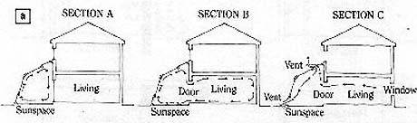
Figure 4a: One-story sunspaces: winter, sunspace cut off from the house (Section A); winter, sunspave helps the lower story via open doors (SectionB); summer, sunspace helps cool the lower story by pulling in air from the north windows (Section C).

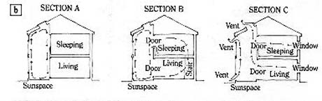
Figure 4b: Two-story sunspace: winter, sunspace cut off from the house (Section A); winter, sunspace helps heat both stories of the house (SectionB); summer, sunspace helps cool booth stories(SectionC).
If you plan to include a sunspace in your design, you'll first need to decide on the primary function of the space. The design considerations for a food-growing greenhouse, a living space and a supplementary solar heater are very different, and although it is possible to build a sunspace that will serve all three functions, compromises will be necessary.

The Sunspace / Greenhouse
A greenhouse, for instance, should be a comfortable and healthy home for plants. Plants need fresh air, water, lots of light, and protection from extreme temperatures. Greenhouses consume considerable amounts of energy through evapotranspiration and the evaporation of water. One pound of evaporating water uses about 1,000 BTU's of energy that would otherwise be available as heat.
To stay healthy and free of insects and disease, plants need adequate ventilation, even in winter. There are air handling systems such as air-to-air heat exchangers that ventilate while retaining most of the heat in the air, but these add significantly to the cost of the project. The light requirements of a space for growing plants call for overhead glazing which complicates construction and maintenance, and glazed end walls, which are net heat losers.
There will be some economic gains from reduced grocery bills if you grow vegetables, and certainly there is much to be said for the sense of satisfaction that comes with increased self-reliance and the aesthetics of a roomful of healthy plants attached to your house. The bottom line in terms of energy efficiency, however, is that a sunspace designed as an ideal horticultural environment is unlikely to have any energy left for supplementary space heating.

Solar Heat Collector
If the purpose of the sunspace is to collect solar heat and distribute it effectively to the adjacent living space, you're faced with a different set of design criteria. Maximum gain is achieved with sloped glazing, few plants, and insulated, unglazed end walls.
Remember that you'll get more usable heat into your living space if there aren't plants and lots of mass soaking it up in the sunspace. Sun-warmed air can be moved into the house through doors or operable windows in the common wall, as well as blown through ductwork to more remote areas.

Living Space
If your sunspace will be a living space, you'll need to consider comfort, convenience, and space in addition to energy efficiency. A room you plan to live in must stay warm in the winter, cool in the summer, have minimum glare levels, and moderate humidity.
Vertical glazing is the choice of increasing numbers of designers for a variety of reasons. First of all, although sloped glazing collects more heat in the winter, it also loses significantly more heat at night, which offsets the daytime gains. Sloped glazing can also overheat in warmer weather, usually the spring and fall, when you don't want the gain.
The performance of a vertical glazed south wall more closely follows the demands of heating degree days, heating effectively in winter when the angle of the sun is low and allowing less solar gain as the sun rises toward its summer zenith. A well-designed overhang may be all that's necessary to keep the sun out when it's not needed. Vertical glazing is also cheaper and easier to install and insulate, and is not as prone to leaking, fogging, breakage and other glazing failures.
A sunspace designed for living requires carefully sized thermal mass, and, as we mentioned earlier, special care must be taken to assure that the sun can get to the mass. A masonry floor covered with carpets and furniture is obviously not as effective a thermal mass as masonry sitting in direct sunlight.
Once the sun goes down, the same windows that collected heat all day begin to reradiate heat to the outdoors. To minimize nighttime losses and maximize comfort (the human body also radiates heat to a cool surface), you may want to include movable window insulation in your design or investigate some of the new high tech glazings now commercially available

Design Guidelines
Regardless of the design strategy you choose, there are some other criteria that are important to consider. Much of the following information is taken from The Sunspace Primer: A Guide to Passive Solar Heating, by Robert W. Jones and Robert D. McFarland, (Van Nostrand Reinhold Co., New York, New York, 1984).

Glazing:
The ideal orientation for the glazing in your sunspace is due solar south, although an orientation within 30o east or west of due south is acceptable. For maximum solar gain, the glass should be tilted 50-60o from the horizon. Many designers, depending on their design strategy, prefer vertical glazing, or a combination of vertical and sloped glazing.
Vertical south-facing glass has advantages over angled glazing in not having to be sealed against water leakage and in its capacity to reflect unwanted (high angle) summer sun, but its winter performance is 10-30% lower that tilted glass of the same area. (Vertically glazed space, can be used like most other rooms in the house, whereas tilted glazing results in head height problems sometimes). The efficiency of a sunspace that combines vertical and some angled roof glazing will be higher than the vertically glazed sunspace, while retaining the advantages of vertical glazing. Rain and snow will clean the outdside of the tilted glass pretty well, whereas vertical glass has the same maintenance problems as house windows. A two-to-three foot wide edging of pea gravel below sunspace glazing that is close to the ground, will prevent soil from splashing onto the glass, which can reduce efficiency.

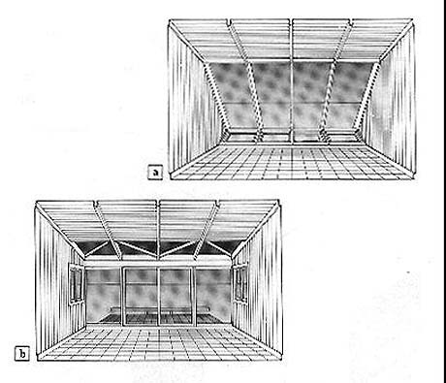
Figure 5: Sunspace with sloped south-wall glazing over reverse-slope vent windows (a). Sunspace with vertical south-wall glazing (sliding door), side venting windows, and sloped roof glazing (b). (Design by Dennis Holloway, Architect)

Heat Storage:
If the sunspace is deeper than it is high, the space itself will trap the radiation, so lighter surface colors are acceptable. Otherwise, the surfaces of heat storage materials (thermal mass) should be dark colors of at least 70 percent absorptance. To give you some perspective on the relative absorptance of various colors, black has an absorptance of about 95 percent, a deep blue about 90 percent, and deep red about 86 percent. Non-storage materials should be lighter colors, so they will reflect light to the thermal mass that isn't in the sun.
The floor, north wall, and east and west side walls are good locations for mass walls, which should be materials with a high thermal conductivity such as concrete, water, brick, adobe, or rammed earth. "Light weight" concrete is not acceptable as a thermal mass material, and concrete is most effective in 4 to 6 inch thicknesses. If concrete blocks are used, the cores must be grouted solid.

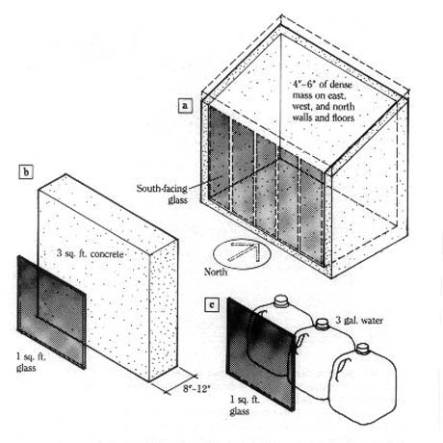
Figure 6: Sunspace thermal storage (a) Provide 3 square feet of concrete (b) or 3 gallons of water (c) for each square foot of glazing.
If the masonry floor and wall mass are the only thermal storage materials in the space, three square feet of masonry surface per square foot of south glazing is the recommended ratio. If water in containers is the only heat storage medium used, the recommended ratio is three gallons per square foot of glazing.
Increasing the amount of mass will stabilize the internal temperatures, making the space more comfortable for people and plants. A common strategy is to use an 8 to 12 inch uninsulated masonry wall as the north wall of the sunspace. The wall is left uninsulated so that the heat from the sunspace can be conducted through to the interior of the house.

Conservation
If the sunspace is to be used for growing plants or as a living space, a minimum of double glazing is recommended. Single glazing loses a great deal of heat at night, and will make the space uncomfortable for plants and people. Movable insulation or a higher-R glazing system will greatly improve the performance of the glazing.
Either of these options adds to the cost of the project, and the obvious disadvantage of movable insulation is that someone has to move it every day, and some designers refuse to use it because of an "objectionalble appearance"--something this industry has not been creative about. On the other hand, it is possible to have the insulation controlled automatically with motors and thermostats, and insulation can provide privacy, summer shading, and increased comfort on cold winter nights.

Distribution
To distribute the warmed air from the sunspace to the rest of the house, openings are strategically placed in the common wall between the sunspace and the interior living space. Heat is transferred by the "thermosiphoning" circulation of the air. Warm air rises in the sunspace, passes into the adjoining space through the opening and cool air from the adjoining space is drawn into the sunspace to be heated as the cycle repeats.
If the openings are 6'8" doors, the minimum recommended opening is 8 square feet of opening per 100 square feet of glazing area. If two openings are used--one high in the sunspace, one low--with 8 vertical feet of separation, the recommended minimum area for each opening is 2.5 square feet per 100 square feet of glazing.

Controls
Sunspaces can radically overheat resulting in dead plants and unusable living spaces if operable vents are not included in the overall design. As we mentioned, overheating is most likely to occur in the late summer and early fall, when the sun is lower in the sky and the outside air temperature is still warm during the day.
Vents are placed at the top of the sunspace where the temperature is the highest, and at the bottom of the space where temperatures are the lowest to induce the chimney effect. Thermostatically controlled motors can be installed to open the vents automatically if no one will be home to operate them.
These paired vents should be sized according to the following specified fraction of the sunspace glazing area. The required vent area is a function of the glass slope, the vertical distance between the top and bottom vents (stack height), and the rise in internal temperature over outdoor temperature that can be tolerated in the sunspace. The last column in the chart gives fan sizes that will provide the same ventilation.
Few design strategies offer the aesthetic appeal and practical paybacks that a carefully thought out and constructed sunspace does. In our view, it is money well spent to take your preliminary design to a solar engineer or architect for feedback and a computer analysis. It is much less expensive to make changes on paper than to alter a design once it's built.

Passive Solar Techniques 2: Indirect Gain
The second passive solar house type, indirect gain, collects and stores energy in one part of the house and uses natural heat movement to warm the rest of the house. One of the more ingenious indirect gain designs employs the thermal storage wall, or Trombe wall placed three or four inches inside an expanse of south facing glass. Named after its French inventor, Felix Trombe, the wall is constructed of high density materials--masonry, stone, brick, adobe, or water-filled containers--and is painted a dark color (like black, deep red, brown, purple or green) to more efficiently absorb the solar radiation.
Some designers use "selective surface" materials, chrome-anodized copper or aluminum foils with adhesive backing that can increase the absorbtive efficiency of the wall to 90%, compared to 60% for a painted surface. These materials allow the wall to absorb radiant heat, but drastically reduce the amount of heat that is lost by radiation to the outdoors at night.
Some builders have had difficulty getting good adhesion between commercially available selective surface foils and the Trombe wall. According to the July 1, 1985 Solar Energy Intelligence Report, Los Alamos National Laboratory is testing a selective surface paint that may hold promise. If you would like to know more about it, contact the National Technical Information Service, 5285 Port Royal Road, Springfield, VA 22161, (703)487-4600, and ask for the report on "Thickness Insensitive Selective Surface Paint." The paint can be brushed or sprayed on, and performs in range of 10-20 percent better than flat black paint.
Heat collected and stored in the wall during the day, slowly radiates into the house even up to 24 hours later. The Trombe wall allows efficient solar heating without the elare and ultra-violet light damage to fabrics and wood trim that is common in direct gain solar homes. Trombe walls also afford privacy in situations where that is an issue.
Perhaps the most useful book on passive solar design for owner-builders is THE PASSIVE SOLAR ENERGY BOOK, by Edward Mazria, who makes the following recommendations for sizing the Trombe Wall: "In cold climates (average winter temperatures 20o to 30o F) use between 0.43 and 1.0 square feet of south-facing, double-glazed, masonry thermal storage wall (0.31 and 0.65 square feet for a water wall) for each one square foot of floor space area. In temperate climates (average winter temperatures 35o to 45o F) use between 0.22 and 0.6 square feet of thermal wall (0.16 and 0.43 square feet for a water wall) for each one square foot of space floor area."

Trombe Wall Vents:
In several of the earliest published Trombe wall houses, small vents were used in the top and bottom of the wall; heated air in the wall air space would rise and pass through the upper vent into the high space of the room, while cooler air from low in the room would be drawn into the wall air space through the low wall vent to form a convective heating loop. This is particularly effective in a building where heat is required quickly. The convective movement of air in the wall results in a significant decrease in efficiency over time. Vented Trombe walls are known to be only about 5% more efficient, overall, than non-vented Trombe walls. Therefore, for residences, non-vented Trombe walls are recommended.

Designing the Passive Solar House
When the term, "passive solar" was introduced into the language of professional solar researchers in the 1970's, most people didn't have a vague notion what it meant. Later, as the term was popularized by the media and through a large number of public educational conferences, people probably thought that if they wanted to build a passive solar house they would have to hire not only an architect, but a professional solar engineer capable of manipulating very complex mathematical equations on a computer.
Today, thanks primarily to knowledge gained from government-funded research and a large number of completed "pioneer" passive solar houses that we've collected data from, we are at the stage where even a high school student can design a passive solar structure. Following is a composite of recently published information to get the owner-builder on the path to owner-designing the passive solar house.

Passive Solar Preliminary Design Rules of Thumb

Orientation:
Remember that "solar south" is different from "magnetic south." The longest wall of the house should ideally be facing due (solar) south to receive the maximum winter and minimum summer heat gains. However, the south wall can be as much as 30o east or west of solar south with only a 15% decrease in efficiency from the optimum.
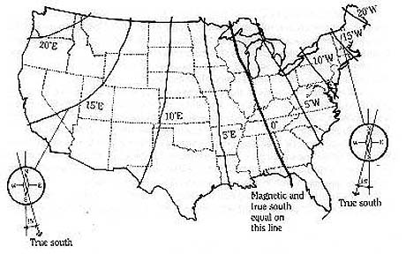
Figure 7:When designing a solar home, you must locate true (solar) south, not magnetic south. This map shows how magnetic south varies from true south in different parts of the United States.

Buffer Zone:
Design your house so that rooms with relatively low heat and light requirements, those that get infrequent use (storage, utility room, garage, e.g.), and those rooms that generate high internal heat (kitchen) are located on the north side of the house to reduce winter heat load.
In 1983 J. Douglas Balcomb and the research team at Los Alamos National Laboratory issued a set of direct gain and indirect gain design guidelines for heating passive solar houses located in the U.S. They included information on infiltration rates and selecting R-values for the walls, ceiling, perimeter, and basement. They also made suggestions about what kinds of glazings to use for east, west and north windows, as well as about how to size the solar collection area.
The technique is not a substitute for more rigorous computer-simulated thermal analysis by a professional engineer, but it gives owner-builders a solid basis for the schematic design decisions. It is an elegant if oversimplified tool for deciding on a good mix of conservation and passive solar strategies based on geographical location. The five-step technique has been distilled from theoretical analysis and from data collected at actual passive solar houses.

STEP 1: Conservation Levels

Locate your building site on the map (Figure 8) to select the Conservation Factor (CF) to be used in your house design. Note that for each geographic zone the CF is expressed as a range. If your fuel costs are high (and whose aren't nowadays!), select the highest number.

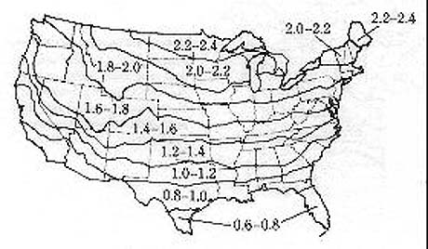
Figure 8: Use this map to find your conservation factor (CF). (Source: J. Douglas Balcolm, et al.)

STEP 2: Recommended Insulation Values and Infiltration Rates
Use the following formulas to determine insulation values and recommended infiltration rates. (CF is the conservation factor you selected in the first step.)
Wall R values: Multiply the CF by 14. This is the R-value for the entire wall, includeing insulation, siding, interior sheathing, etc.
Ceiling R-values: Multiply the CF by 22. This is the R-value for the entire ceiling, including insulation, finish surface, etc.
R-value of rigid insulation placed on the perimeter of a slab foundation: Multiply CF by 13. Subtract 5 from this number. Use the same value for the insulation of the floor above a crawl space or for the perimeter insulation outside an exposed stem wall.
R-value of rigid insulation applied to the outside of the wall of a heated basement or bermed wall: Multiply CF by 16. Subtract 8 from this number. Use theis value for insulation extending to 4 feet below grade. Use half this R-value from 4 feet below grade down to the footing.
Target ACH (Air Changes/Hour): Divide .42 by the CF. If the result is lower than 0.5ACH, choose tight superinsulation techniques with controlled ventilation to maintain indoor air quality.
Layers of glazing on east, west, and north windows: Multiply the CF by 1.7, then choose the closest whole number. (If the number is 2.3 , choose windows with three layers.) If the number exceeds 3. explore insulating glass and/or movable insulation.
Based on guidance from results of these formulas, select your conservation levels, trying to stay within 20% of the results. Your budget will be your best guide, but remember that conservation pays in the short and long run, so when in doubt, opt for higher conservation levels.

STEP 3: Net Load Coefficient
We next compute a Net Load Coefficient (NLC). To do this, look up your home's geometry factor (GF) in Table 1 (below). For example, if the house will have a total floor area of nearly 3000 square feet on three stories, the GF will be 5.7.
Now multiply the GF by your house's floor area. Thus, if the floor area will be 2900 square feet and the GF is 5.7, you multiply these two values to get 16,530. Finally, divide this result by the CF. If your CF is 2.0, for example you would divide 16,530 by 2 to get 8265. This is your NLC.
Table 1: Geometry Factor, GF
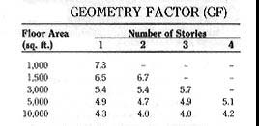

STEP 4: Load Collector Ratio
Locate your building site on the following Load Collector Ratio (LCR) map (Figure 9). This will give you the lad collector ration (LCR) for your home. Note that for each geographic zone, the LCR is expressed as a range. If your fuel costs are high, select the lowest number.
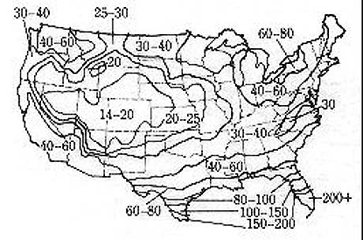
Figure 9: Use this map to find your load collector ratio (LCR). (Source: J. Douglas Balcomb, et. al.)

STEP 5: Passive Solar Glazing Area
To determine the area of the passive solar collector (Trombe wall, sunspace, etc.) for your home, divide the NLC (the number you got in step 3) by the LCR (the number you got in Step 4). For example, if your NLC is 8.265 and your LCR is 20, then your passive solar collector should have 423 square feet of south-facing glazing. You can round this number up or down by 10 percent (so the area could be as small as 370 square feet or as large as 450 square feet.) In hot climates, the areas should be adjusted downward by 20 to 30 percent.

Passive Solar Concepts
Elements most commonly used in passive solar homes to make maximum use of the sun's heat include direct-gain windows, direct gain glazed solariums, and indirect-gain Trombe walls and mass wall. Each of these elements will influence the design because they have specific requirements.
"Direct-Gain" windows allow sunlight to enter the home directly. Much of the heat from the sunlight should be absorbed by some type of high-density material such as masonry; after sunset, the heat will flow out of this "thermal mass", helping to keep the house warm. Direct-gain windows should be oriented due south, although the orientation may be varied by as much as 30 degrees east or west of south without losing much efficiency. Southerly views from the building site become an important criterion in site selection--you don't want huge southern windows showing you unattrative views. Because many furniture fabrics and carpets are susceptible to fading in sunlight, and because these materials tend to prevent the light from reaching masonry floors where its warmth can be stored, you should keep such fabrics our of direct sunlight.
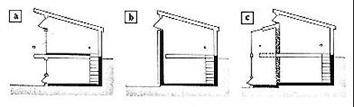
Figure 10: A large south-oriented glass wall and high vents (a); A Trombe wall (b); A two-story sunspace (c). Thermal mass is shown as solid black and speckled areas.
The direct gain solarium (otherwise known as a solar greenhouse or sunspace) is similar in concept to teh direct-gain window, and the same orientation rules of thumb apply. The typical early solarium of the 1970s projected out from the house, like na addition, and was glazed on the south, east, and west sides as well as the roof. The south wall was typically sloped. Today's solarium has been modified for greater efficiency and typically is flush with the south wall of the house, therby eliminating the loss of energy from the east and west walls. Surrounded by other spaces, the solarium space can be an effective focus for the house, functioning like a solar "hearth". To minimize the overheating common in the early style solarium, the roof is not glazed and the south wall is vertical rather than sloped. The state-of-the-art solarium is sometimes a two-storey space, with French doors opening to rooms on both levels, allowing better circulation of solar-heated air throughout the house.
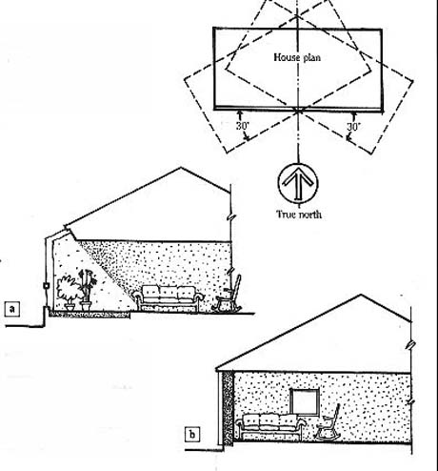
Figure 11: Orientation to true south in a passive solar house may vary by as much as 30 degrees east or west of south with relatively little loss of overall efficiency (top); A direct-gain system, such as a sunspace (a), floods a space with light, which may cause fabrics to fade. An indirect-gain system, such as a Trombe wall (b), provides heat while blocking the light.
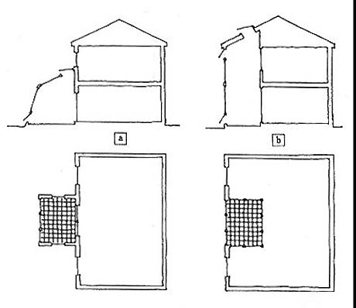
Figure 12: First generation sunspaces (a) usually protruded from the house. New sunspaces (b) are often two story designs set into a house's south wall.
A Trombe wall is a masonry wall with glazing spaced a few inches outside it. Solar heat is trapped between the masonry and the glass; it enters the house by migrating through the masonry. Whereas the direct-gain window and solarium are virtually transparent,creating strong spatial connections between indoors and outdoors, the Trombe wall obstructs views to the outdoors, so it works well on a site where a southern view is not desireable. If you do want a south view, however, yu can place windows in a Trombe wall. Variations on the Trombe wall include half-Trombe walls with direct-gain windows above, and Trambe walls with integral fireplaces. A Trombe wall can also be "bent" or shaped to fit the internal requirements of the floor plan.
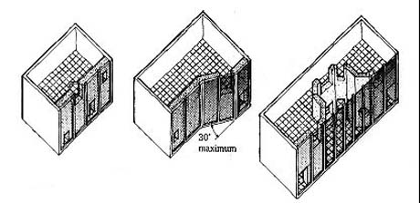
Figure 13: Trombe walls can be designed to fit virtually any south-facing wall.
The design of a multilevel passive solar house should take into account the fact that there will be some degree of heat stratification, with warmer upper level spaces and cooler lower level spaces. Thus the spaces on the upper level might include the living, cooking, and family activity arieas where most of the waking hours are spent, and the lower level spaces could be used for sleeping. Although this "upstairs / downstairs" relationship seems unconventional to us, it offers a better view from the living space and is ideal for a hillside house with entry on the north side of the house and the north walls of the lower level sheltered by the hill.

The Future of Passive Solar Houses
The emergence in the 70's of the passive solar house, in all its variations, was a dramatic display of Yankee ingenuity applied to the national energy crisis, and our knowledge about the solar-thermal performance of buildings was extended by a quantum leap. But at this writing, the political pendulum and its news media has swung away from passive solar architecture, as the Federal solar tax credits quietly are put to bed.
With all the current talk of an emerging energy-glutted decade, the potential owner builder may wonder if making an energy efficiency statement in a new home makes any sense. We surely have to see through this cloud to know that energy shortfall in the 70's will pale by comparison to what lies ahead in the 90's. The growing movement of clear-sighted owner builders will continue to show the rest of the population that our living room comfort can, by connecting to our abundant ambient solar energy, release us from the tyranny of tenuous foreign energy supplies.
In a recent interview, Douglas Balcomb, our foremost passive solar researcher-spokesperson, said that the viability of passive solar has become an established fact, and the use of direct-gain spaces, sunspaces, and Trombe walls (in that order) will be with us for a long time.

Your comments and feedback are welcome. Please contact me via e-mail:
archvr@cybermesa.com

